Solution to limit printing in IE browser

There’s 2 way to do the printing in web browser.

- Use default print component in IE browser by invoking “window.print()” method. But every time the print button is clicked, system printing dialog will show up and maybe the paper type should be reconfigured, like this.
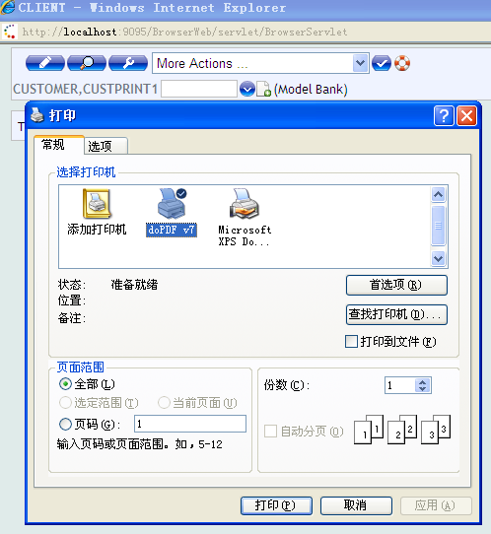

- Use a third-party ActiveX Object like “PAZU”.
“PAZU” works after it is installed to the computer. Either install It’s exe file
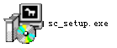
or auto-install while loading the printing page is ok.

With a third-party ActiveX Object, parameters related to the printing, such as printer, paper type, page margin or else, can be configured with javascript and do the printing directly without popup the system printing dialog.
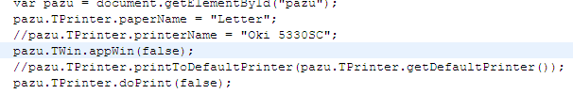

BTW, PAZU’s licence is permanent , Intranet 880 RMB/licence and Internet about 2090RMB/licence. I think what we need is Intranet.
About limit printing times.
Here’s a proved solution.

First, make sure browser open the printing page in “pop up” way, so there will not be “refresh” button and “print” button on the window.
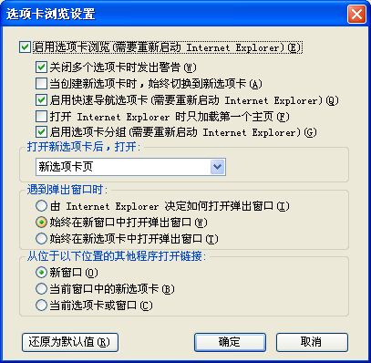
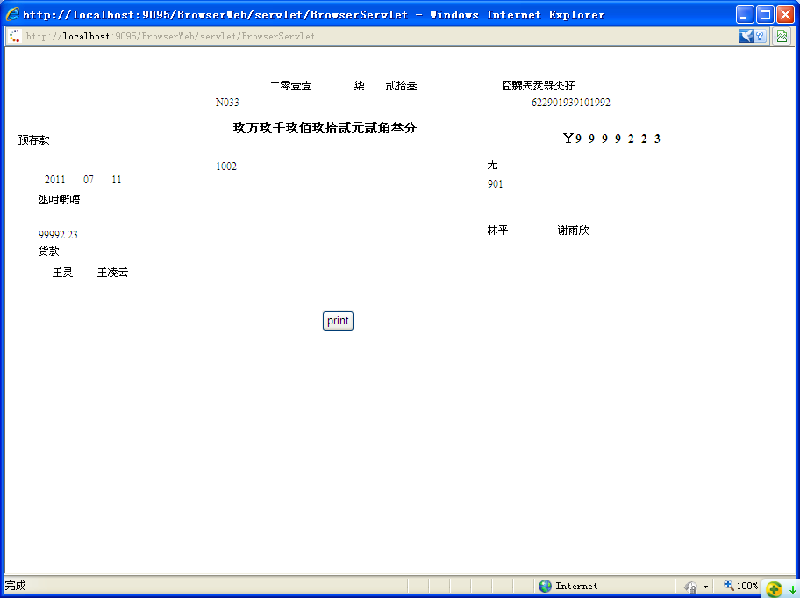

Second , forbid refresh hotkey “ctrl+r” “F5” and print hotkey “ctrl+p” and right-click menu with javascript to prevent any other way of printing.
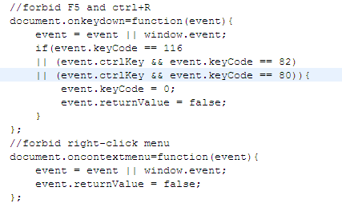

Finally , add a “print” button, and hide it after clicked, in this case, there’s no way to print the page again.
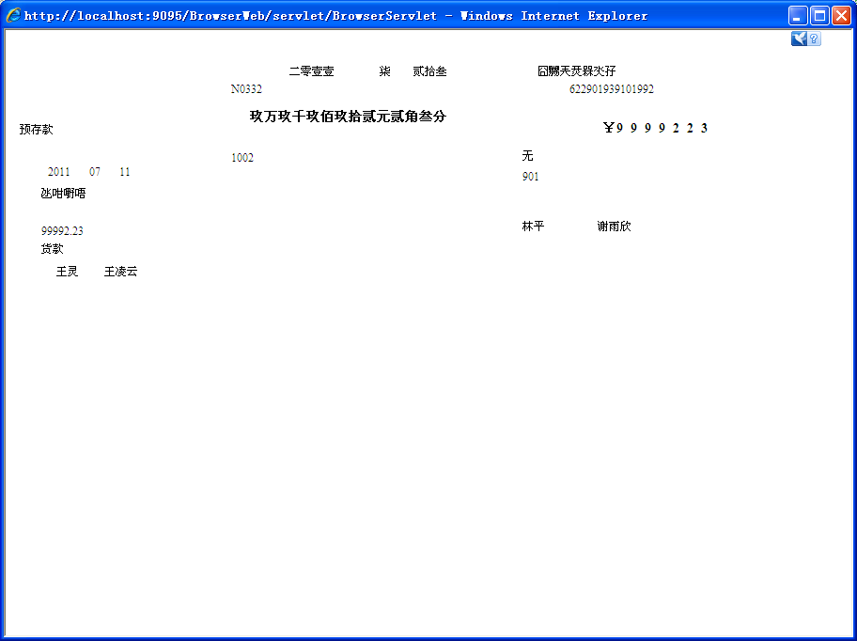

PS: “Internet Options” menu should be disabled in “Group Policy” to prevent Teller from changing the way how printing page opens.

